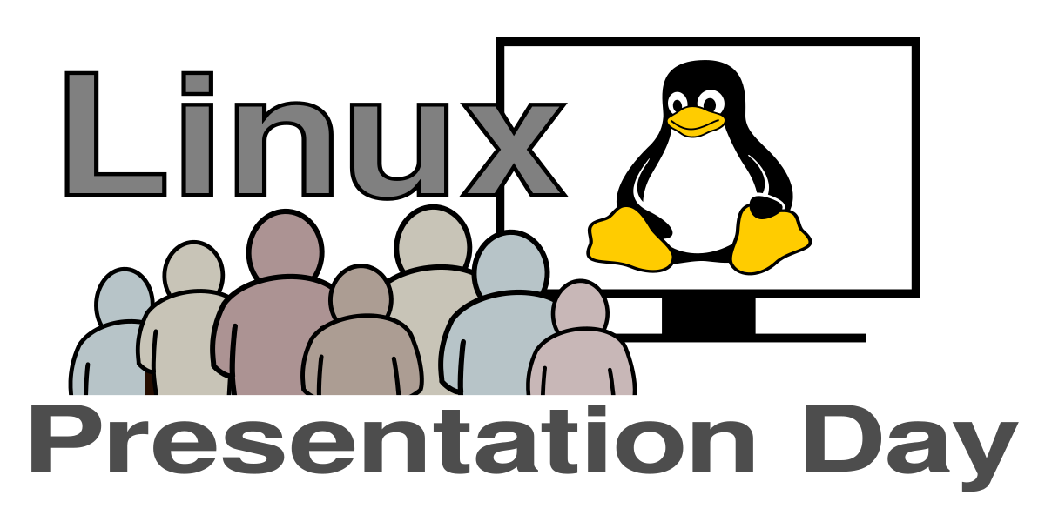

Open source
As the name suggests, with open source software the source (code) is accessible to everyone. Linux is an open source operating system with a huge collection of software, which is also open source.

Free of charge
Software for Linux is usually open source and free of charge. Around the globe many developers work on Linux in their spare time without pay (there are exceptions). Donations are a great way to support projects. Bigger software projects have professionalized handling donations (via an association or foundation).

Open source and secure
Linux has the reputation to be very secure.
Since the source code is constantly inspected by hundreds of people all the time, errors become evident quickly and are also resolved quickly. Once an error was detected, it is openly announced, the software gets updated and is made available as fast as possible. Linux systems usually update automatically - with special focus on security.

Contribute
Open source applications invite people to join and contribute. If you are a developer, a designer, a texter / translater or tester … there's a lot to do and helping hands are welcome.

Perfect for education
Linux is popular in universites. Due to its openness, the principles can be understood clearer and unlock creative potential. By participating in an Open source project you will learn a lot from other experienced contributers.

A small selection
These Open source software you may already know:
- Firefox - the web browser
- Krita - the artistic drawing program
- LibreOffice - the office suite
- Gimp - the image editor
- OBS - the video streaming suite
- Blender - the 3D software
- Audacity - the audio editor

